**TASK 1: IMAGE SEGMENTATION AND DETECTION**

**TASK 1: OBJECT SEGMENTATION**

**Three skin Images report**

1) For three skin images (ISIC_0000019, ISIC_0000095 and ISIC_0000214), you are required to put the original images, final segmented lesion binary images, the calculated DS value for each of the three images;

|  |  |  |  |
| --- | --- | --- | --- |
| **Skin images** | **Original images** | **Final segmented lesion binary images** | **Calculated Dice Similarity value** |
| **ISIC_0000019** | **C:\Users\Computing\Desktop\0000019.PNG** | **C:\Users\Computing\Desktop\19.PNG** | **0.8423** |
| **ISIC_0000095** | **C:\Users\Computing\Desktop\0000095.PNG** | **C:\Users\Computing\Desktop\95.PNG** | **0.6421** |
| ISIC_0000214 | **C:\Users\Computing\Desktop\0000214.PNG** | **C:\Users\Computing\Desktop\214.PNG** | **0.8728** |

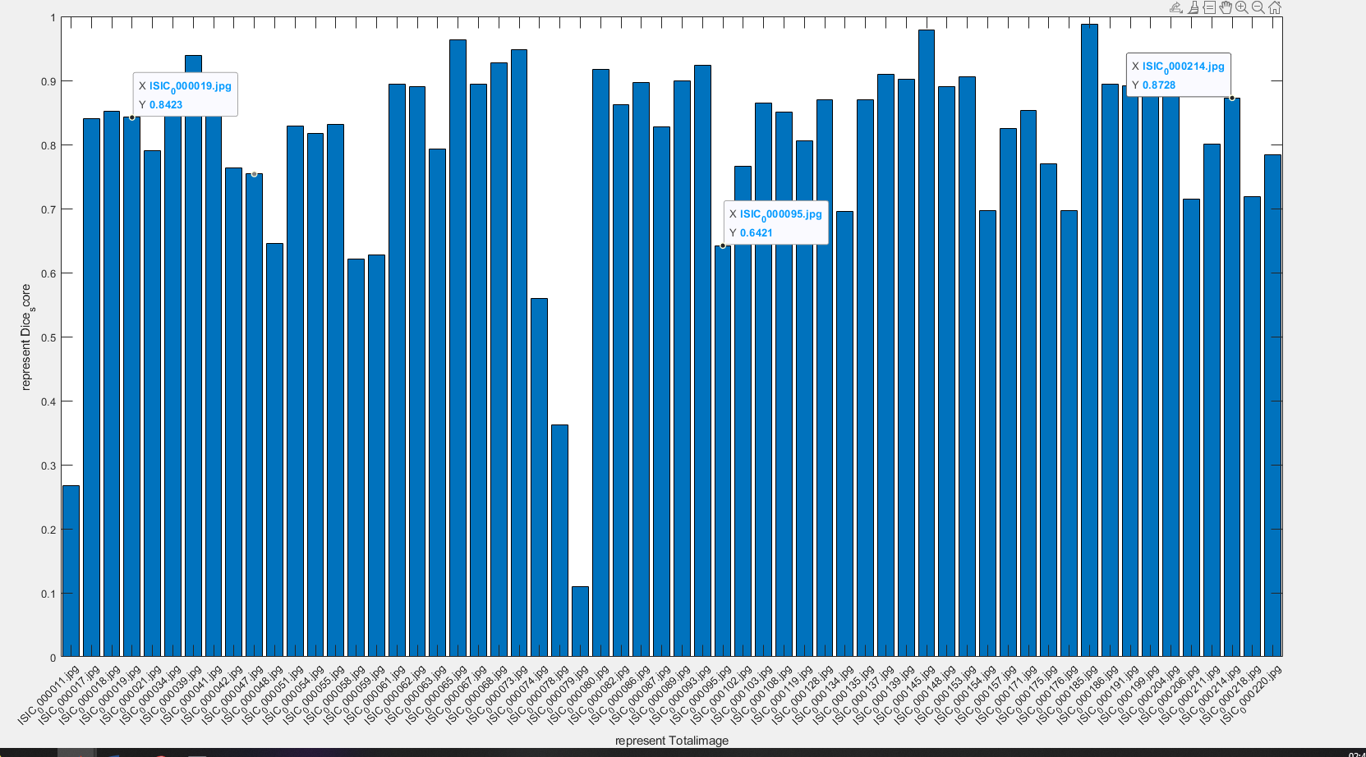

2) For all the 60 skin images, please provide a **bar graph** with x-axis representing the number of the image, and y-axis representing the corresponding

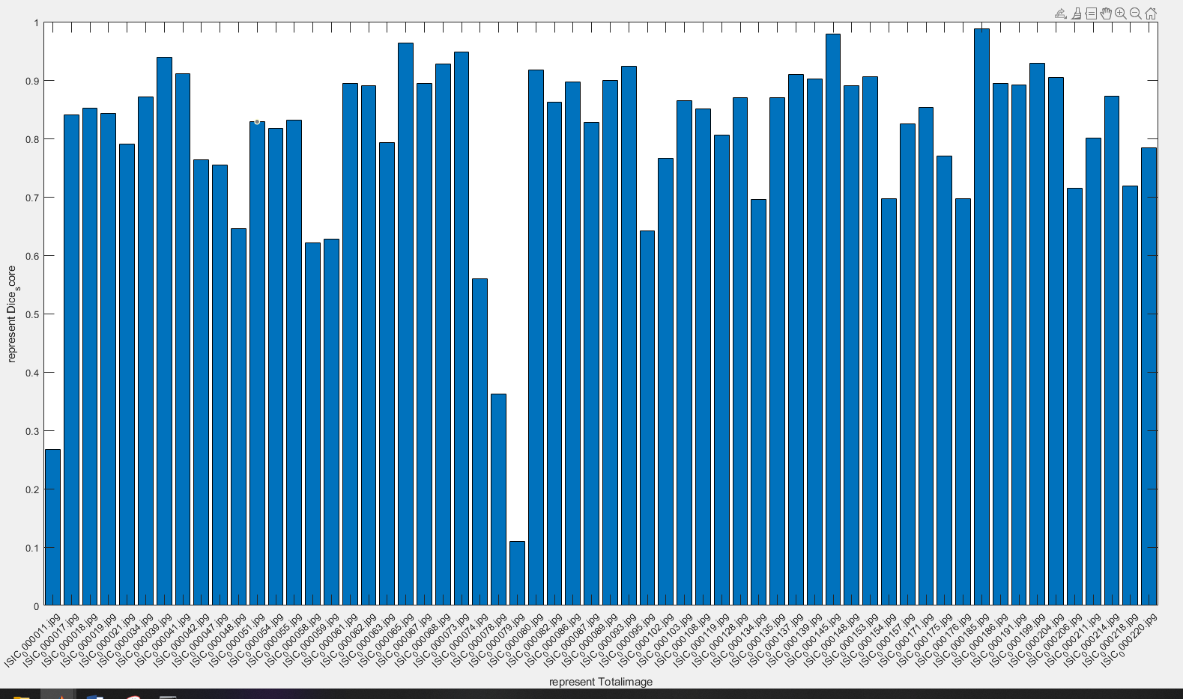

3) Calculate the mean and standard deviation of the DS for all the 60 images.

**Mean = 0.8027**

**Std = 0.1615**

**TASK 2 SEGMENTATION JEVALUATION**

**Dice Similarity score1 for the whole image = 0.7846**

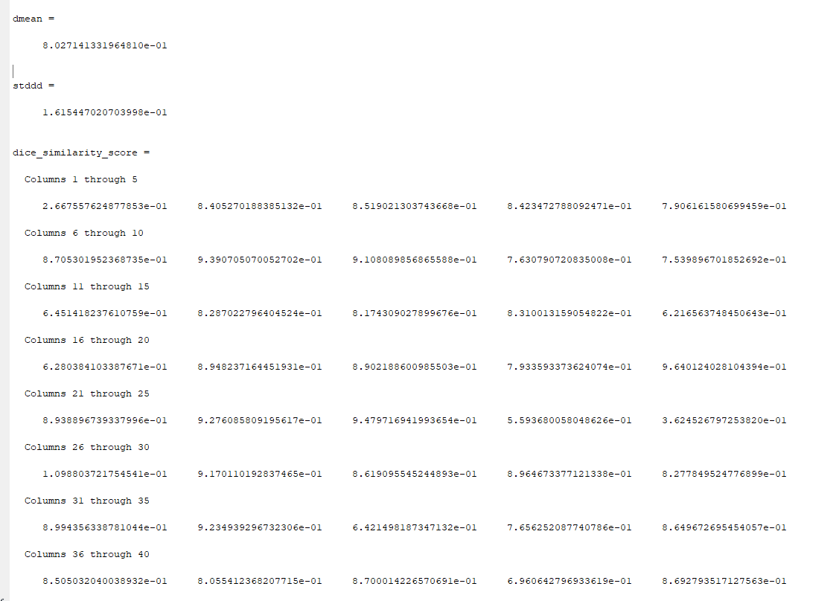

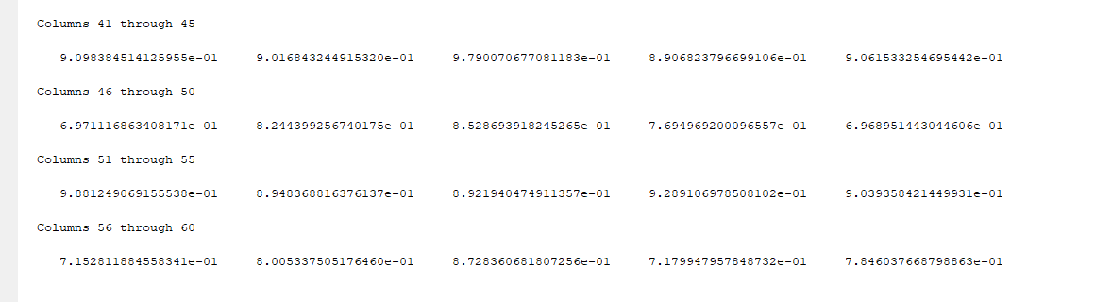

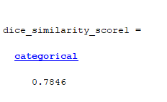

4) Briefly describe and justify the implementation steps

Code Snippet for Task 1

%%

% One Model with the same parameter settings for all the images

clc;

clear;

basefolder = 'C:\Users\Computing\Documents\MATLAB';

segmentation = 'C:\Users\Computing\Documents\MATLAB\segmentation';

imagefiles = dir('C:\Users\Computing\Documents\MATLAB\org data\*.jpg');

groundtruthfiles = dir('C:\Users\Computing\Documents\MATLAB\GT\*.png');

dice_similarity_score=zeros(1,60);

nfiles = length(imagefiles)

for i=1:nfiles

currentfilename =['C:\Users\Computing\Documents\MATLAB\org data\', imagefiles(i).name];

currentimage = imread(currentfilename);

I_gray=rgb2gray(currentimage);

%imshow(I_gray)

I_gray = imbinarize(I_gray);

I_gray = imclose(I_gray, strel('disk',10));

% complement result to get DS score

I_gray = imcomplement(I_gray);

groundtruthfilename =['C:\Users\Computing\Documents\MATLAB\GT\', groundtruthfiles(i).name];

currentgroundtruthimage = imread(groundtruthfilename);

currentgroundtruthimage = imbinarize(currentgroundtruthimage);

dice_similarity_score(i) = dice(I_gray,currentgroundtruthimage);

cd(segmentation)

imwrite(I_gray,imagefiles(i).name);

cd(basefolder)

%images{i} = currentimage;

% i= i+1

end

%%

dmean = mean(dice_similarity_score)

stddd = std(dice_similarity_score)

dice_similarity_score

%%

file_names = dir('C:\Users\Computing\Documents\MATLAB\org data\');

file_names = file_names(~[file_names.isdir]);

file_names = {file_names.name}

file_names1 = categorical(file_names);

dice_similarity_score1 = categorical(dice_similarity_score(i))

bar(file_names1,dice_similarity_score())

xlabel('represent Totalimage')

ylabel('represent Dice_score')